Govt. High School
Sindhi Jamaat Co-Operative Housing Society, Karachi
Parent Teacher Meeting
Total Strength: 101 |  | Class: ECE
Attendants: 45 |  | Date: 25-1-2025
 |  | Time: 9:00 AM to 12:00 PM

Report:
- 3rd PTM was Conducted on 25 January 2025 for ECE Classes. (Delay the date 4th January due to Strength of Students).
- These are the following points we are discuss.
- Progress of Students.
- Syllabus and Time table (Final Term).
- Home Work.
- Attendance.
- Curriculum.
- Healthy Food.
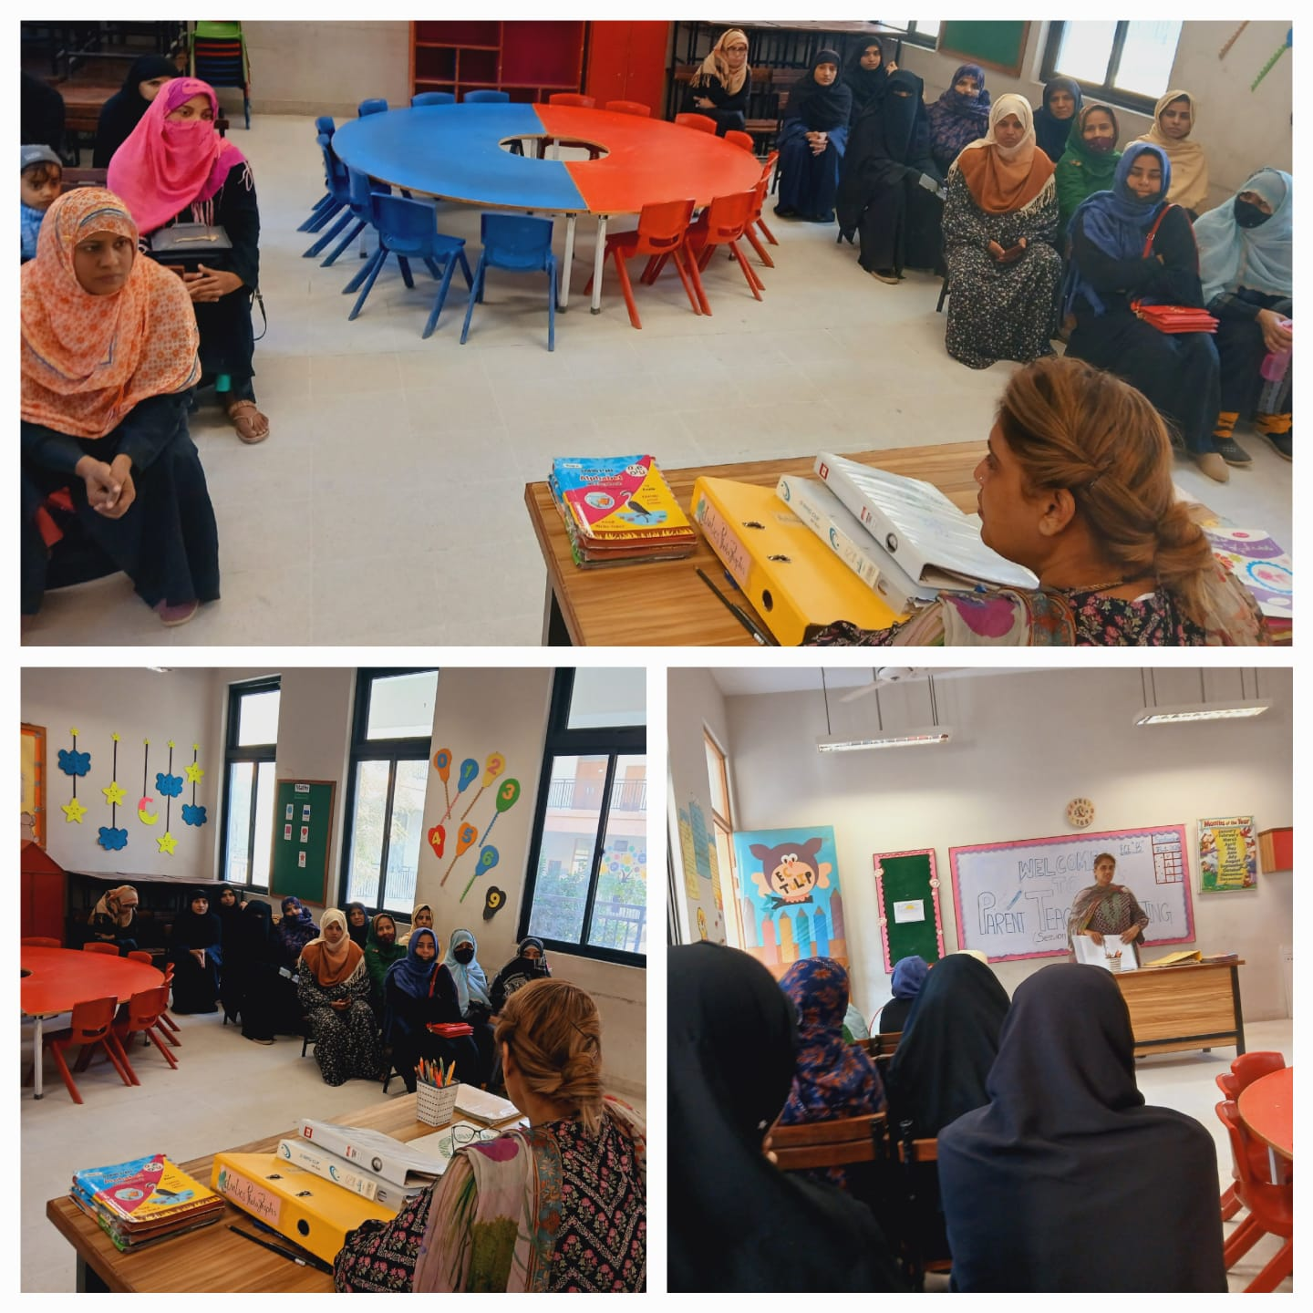
- Cleanness.

Govt. High School
Sindhi Jamaat Co-Operative Housing Society, Karachi
Parent Teacher Meeting
Total Strength: 56 |  | Class: Level-I
Attendants: 23 |  | Date: 1-2-2025
 |  | Time: 9:00 AM to 12:00 PM

Meeting Agenda:
- 3rd PTM was Conducted on 1 February 2025 for Level-I. (Delay the date 4th January due to Strength of Students).
- These are the following points we are discuss.
- Progress of Students.
- Syllabus.
- Announcement of Annual Exams Date.
- Punctuality.
- Participation in co-curricular Activities
Review:
- 23 parents attended this meeting.
- 96% parents were satisfied with school management and studies.
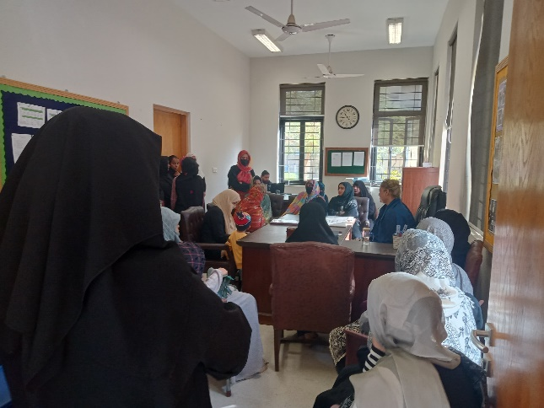
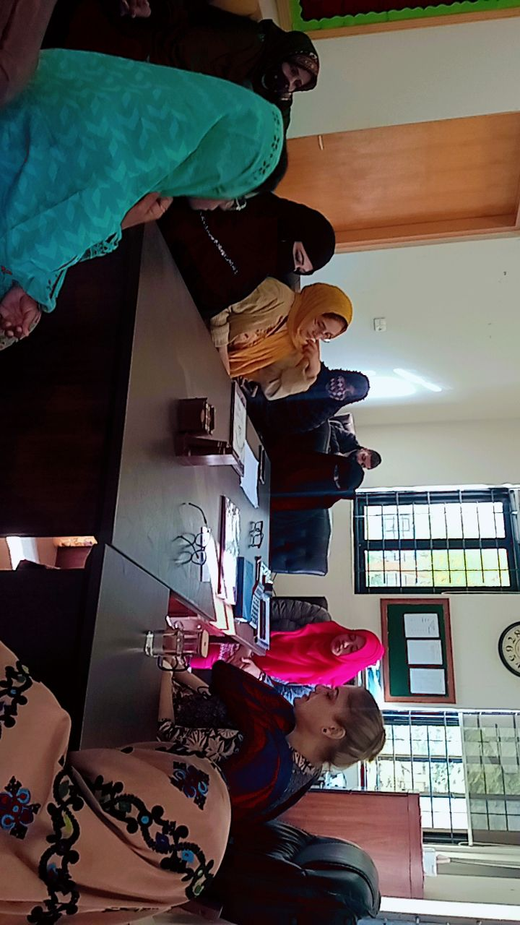
- They assure that they will collaborate with teachers.
Govt. High School
Sindhi Jamaat Co-Operative Housing Society, Karachi
Parent Teacher Meeting
Total Strength: 52 |  | Class: Level-II
Attendants: 38 |  | Date: 1-2-2025
 |  | Time: 9:00 AM to 12:00 PM

Meeting Agenda:
- 3rd PTM was Conducted on 1 February 2025 for Level-II. (Delay the date 4th January due to Strength of Students).
- These are the following points we are discuss.
- Progress of Students.
- Syllabus.
- Announcement of Annual Exams Date.
- Punctuality.
- Participation in co-curricular Activities
Review:
- 38 parents attended this meeting.
- 94% parents were satisfied with school management and studies.


- They assure that they will collaborate with teachers.
Govt. High School
Sindhi Jamaat Co-Operative Housing Society, Karachi
Parent Teacher Meeting
Total Strength: 52 |  | Class: Level-III
Attendants: 41 |  | Date: 1-2-2025
 |  | Time: 9:00 AM to 12:00 PM

Meeting Agenda:
- 3rd PTM was Conducted on 1 February 2025 for Level-III. (Delay the date 4th January due to Strength of Students).
- These are the following points we are discuss.
- Progress of Students.
- Syllabus.
- Announcement of Annual Exams Date.
- Punctuality.
- Participation in co-curricular Activities
Review:
- 41 parents attended this meeting.
- 93% parents were satisfied with school management and studies.


- They assure that they will collaborate with teachers.
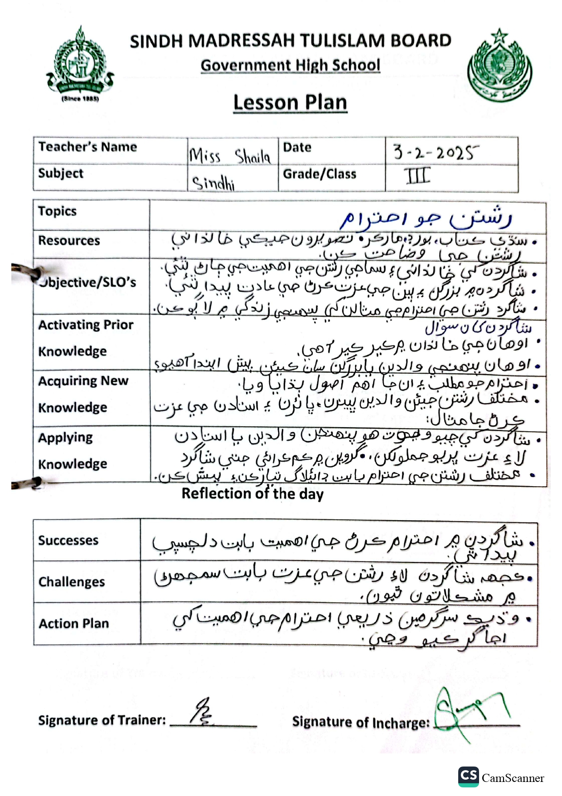
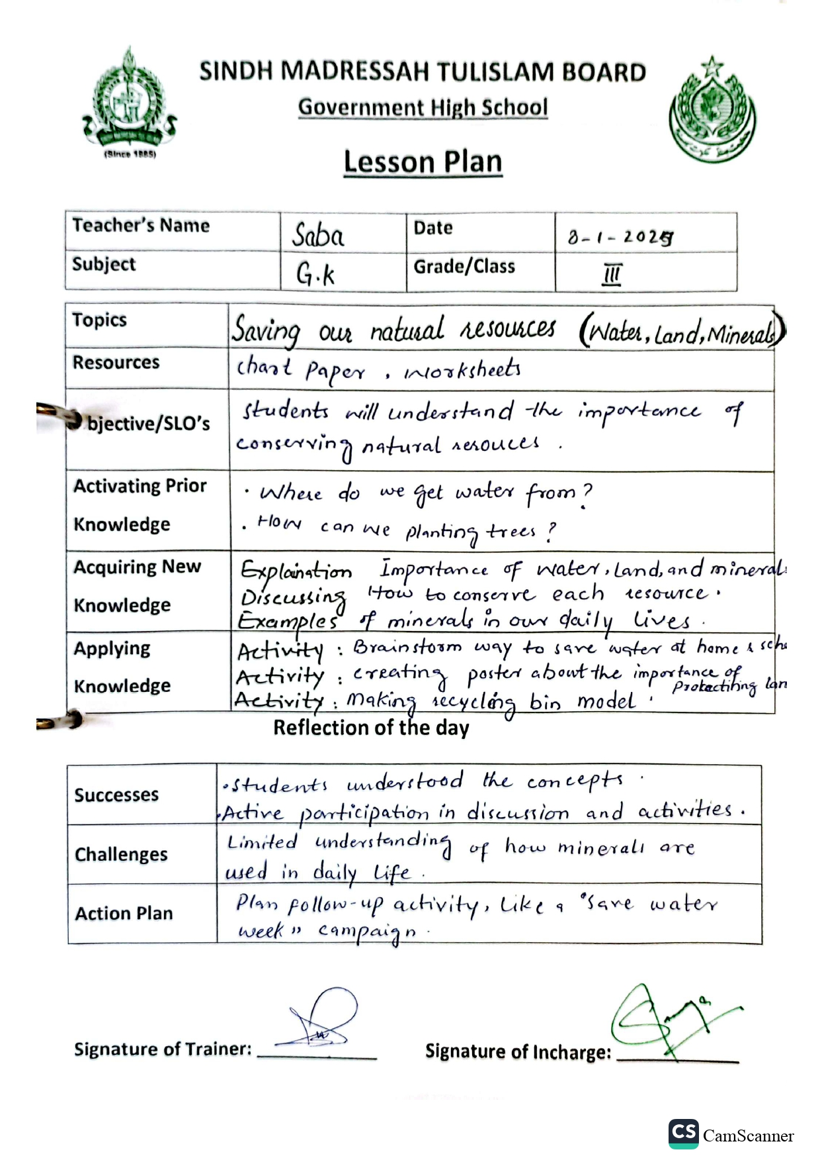
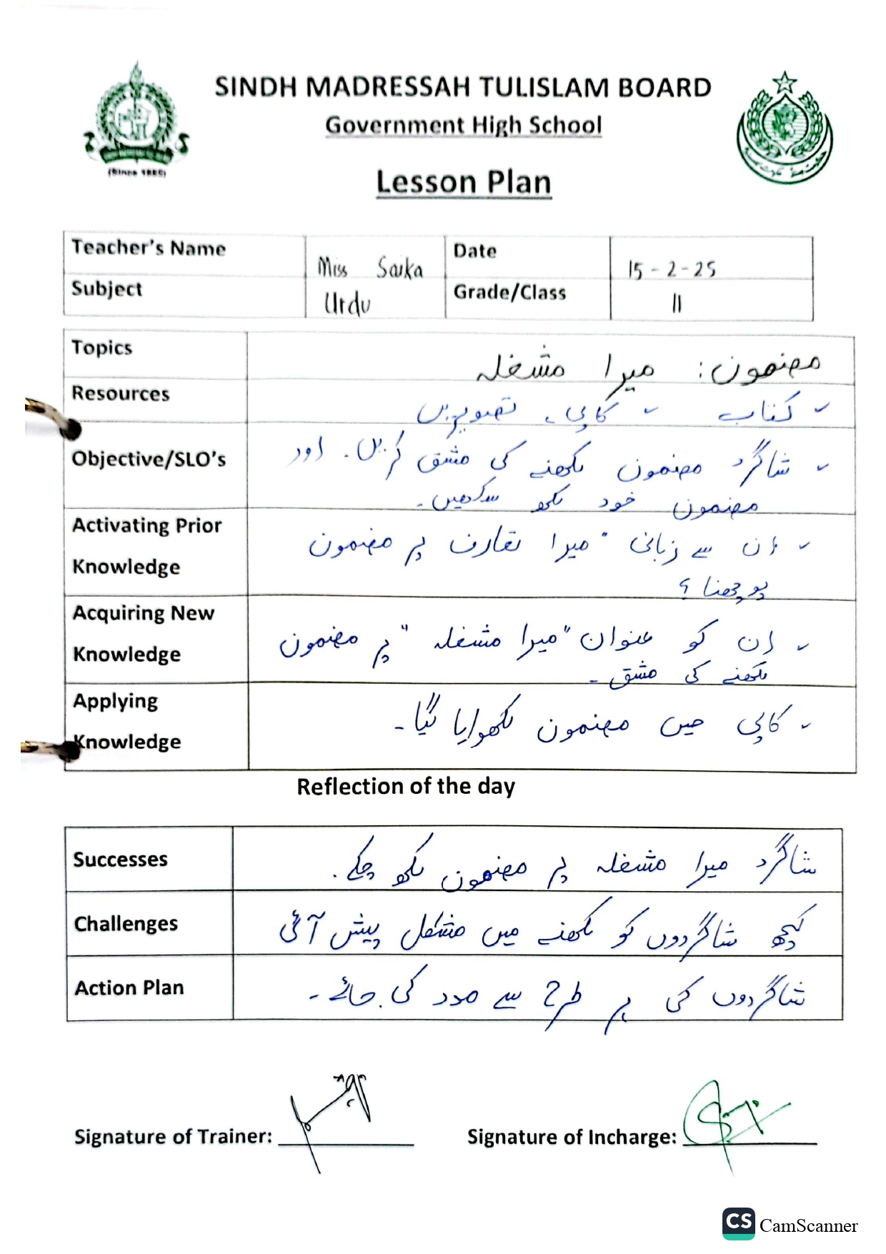

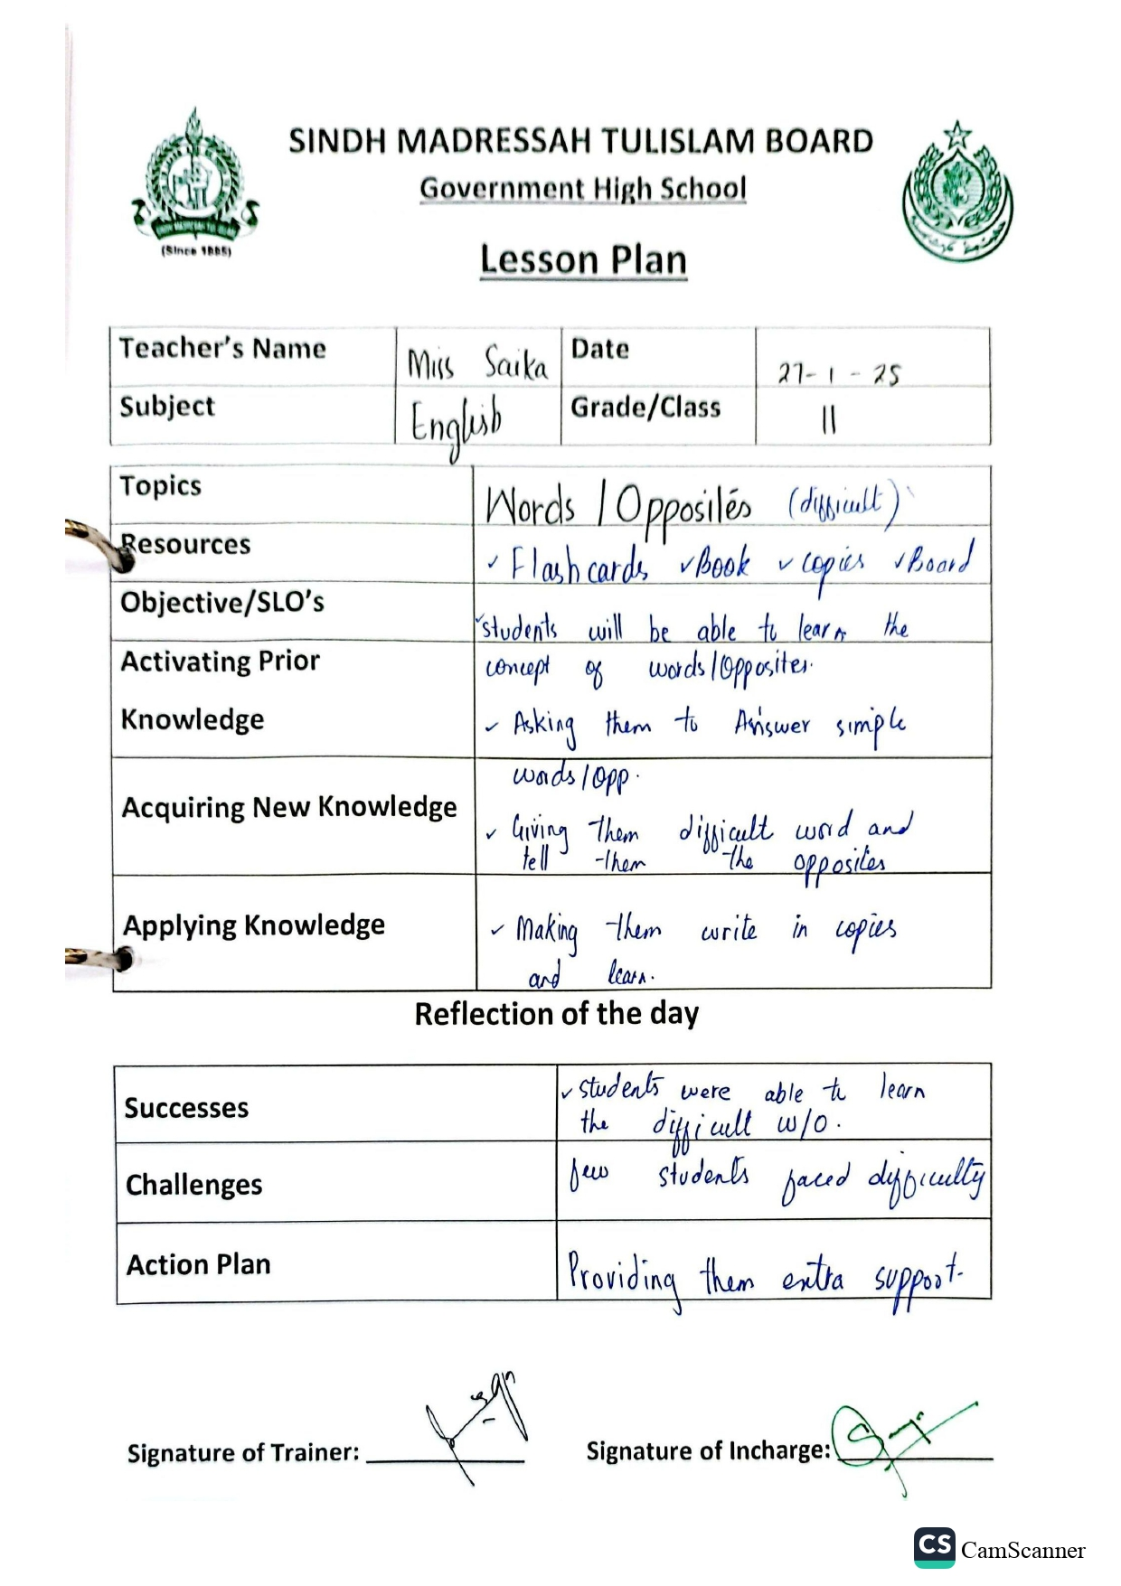
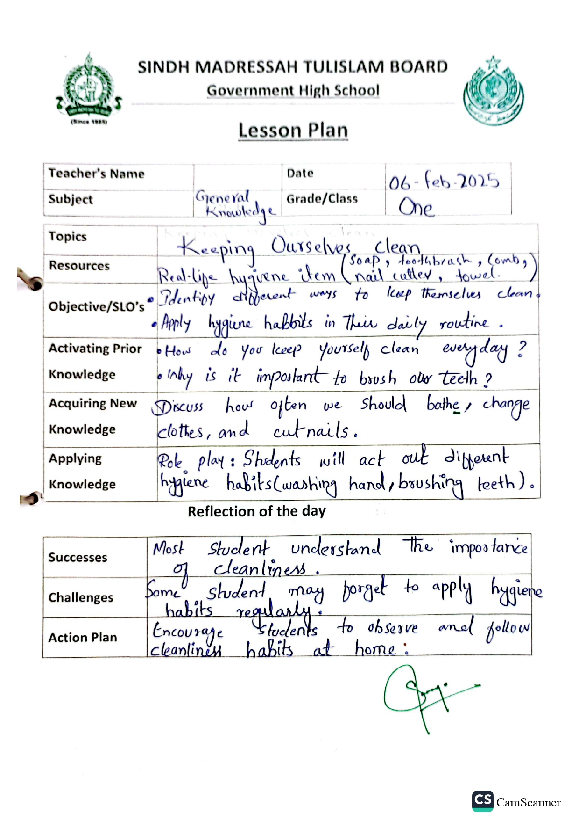
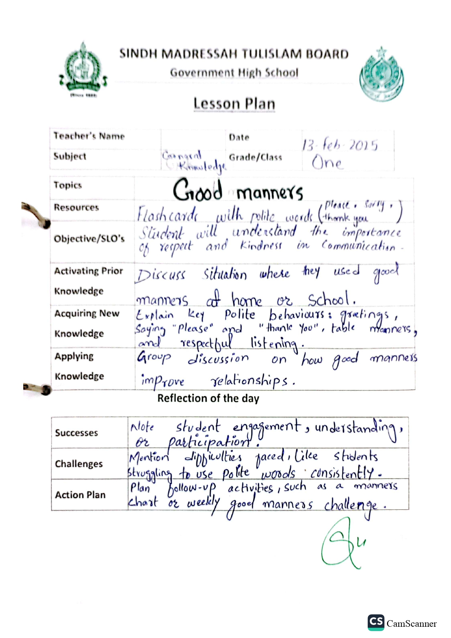
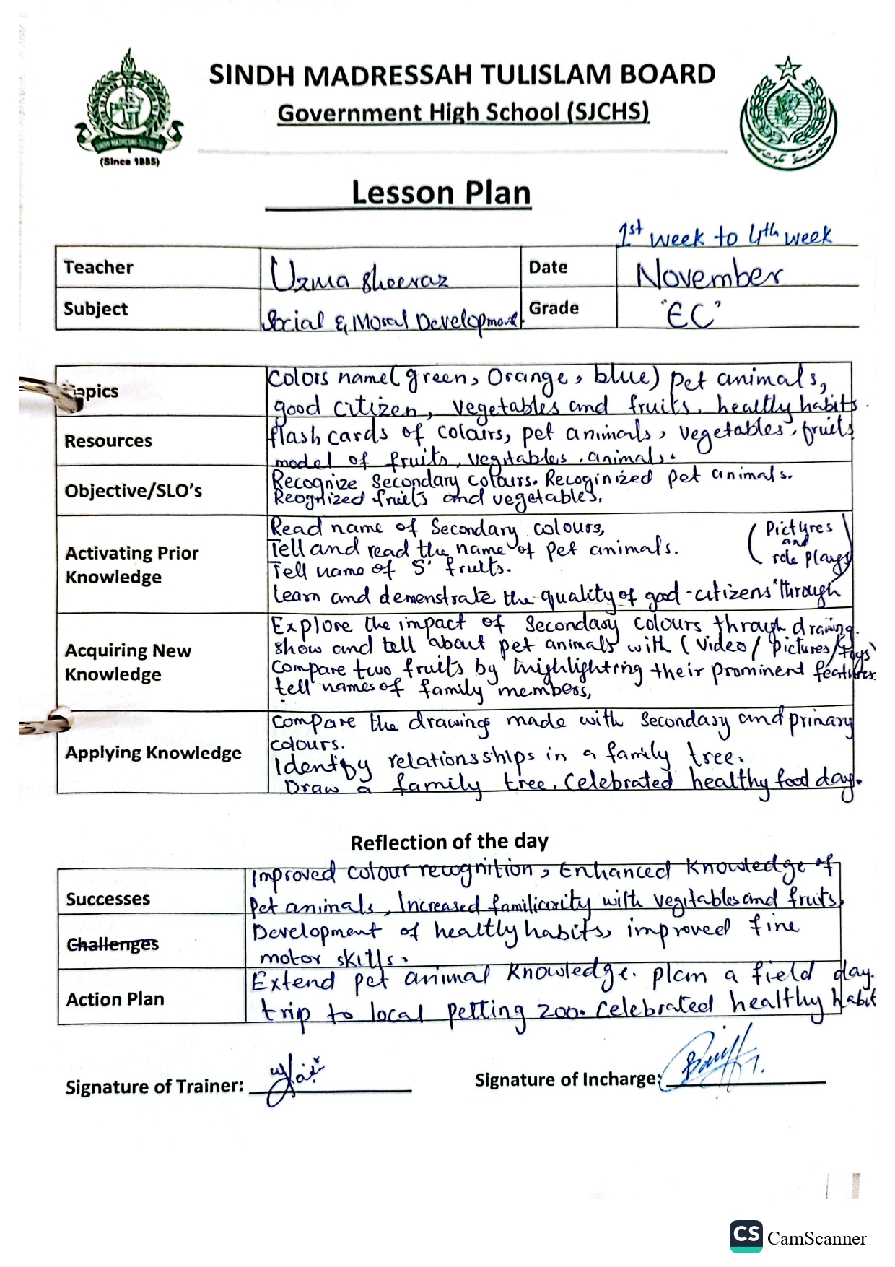
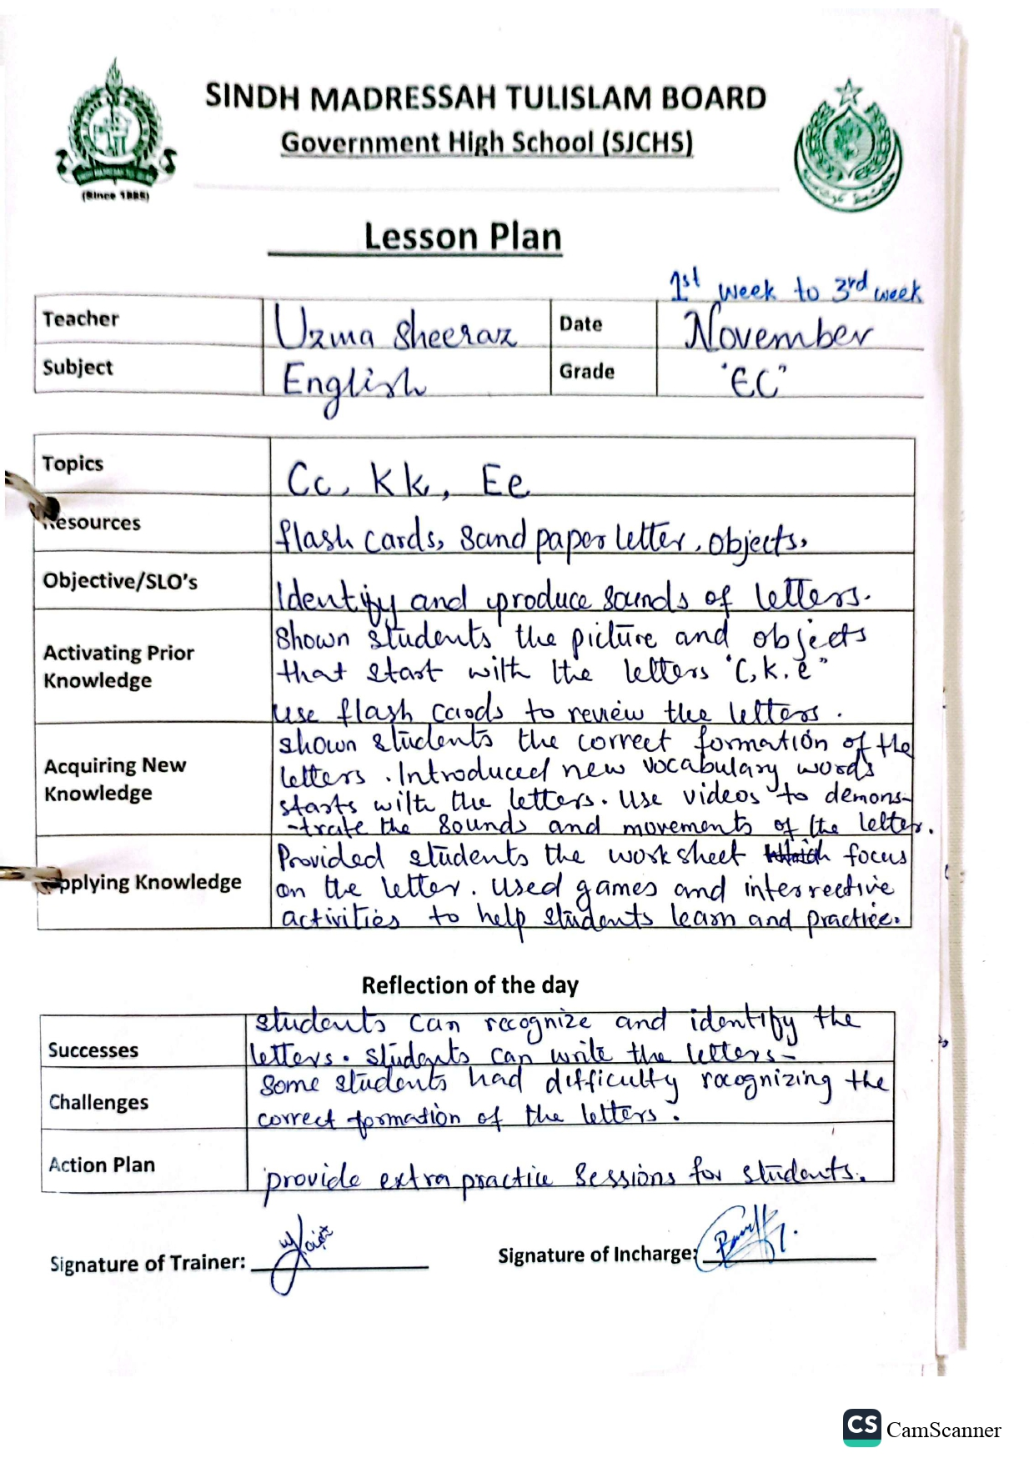

November Attendance

December Attendance
January Attendance
February Attendance
Teaching Staff Available in Schools
School Name | Government / Private | Teaching / Non- Teaching | Subjects / Department | Categories (SST, ST, PST, etc.) | Active (regular) | Transfer In | Deputation | New Hiring | Total
GBPS Sindhi Jamaat Cooperative Housing Society | Govt/Private | Teaching |  | HSTs= 1  JSTs= 1  JESTs=  ECT= 1  O.T=  PET=  SLT=  WI=  ITT=  PST= 9  Private= 8 | 20 | 0 | 1 | 4 | 20
GBPS Haji Shafi Muhammad Goth | Govt/Private | Teaching |  | HSTs= 0  JSTs= 0  JESTs= 0  ECT= 0  O.T= 0  PET= 0  SLT= 0  WI= 0  ITT=0  PST=5  Private 0 | 5 | 0 | 0 | 0 | 5
GBPS Master Allahna Muhammad Hassan Panhwer Goth | Govt/Private | Teaching |  | HSTs= 0  JSTs= 0  JESTs= 0  ECT= 1  O.T= 0  PET= 0  SLT= 0  WI= 0  ITT=0  PST=9  Private= 0 | 10 | 0 | 0 | 0 | 10
GBPS Juvinail Jail near Quaidabad Bin Qasim Town | Govt/Private | Teaching |  | HSTs= 0  JSTs= 0  JESTs= 0  ECT= 0  O.T= 0  PET= 0  SLT= 0  WI= 0  ITT=0  PST=3  Private 0 | 3 | 0 | 0 | 0 | 3

Non-Teaching Staff Available in School
School Name | Government / Private | Teaching / Non- Teaching | Subjects / Department | Categories (SST, ST, PST, etc.) | Active (regular) | Transfer In | Deputation | New Hiring | Total
GBPS Sindhi Jamaat Cooperative Housing Society | Govt/Private | Non-Teaching | Primary | Govt= 1  Private= 8 | 9 | 0 | 0 | 0 | 9
GBPS Haji Shafi Muhammad Goth | Govt/Private | Non-Teaching | Primary | Govt= 1  Private= 0 | 1 | 0 | 0 | 0 | 1
GBPS Master Allahna Muhammad Hassan Panhwer Goth | Govt/Private | Non-Teaching | Primary | Govt= 1  Private= 0 | 1 | 0 | 0 | 0 | 1
GBPS Juvinail Jail near Quaidabad Bin Qasim Town | Govt/Private | Non-Teaching | Primary | Govt= 1  Private= 0 | 1 | 0 | 0 | 0 | 1

